SAMYABRATA BISWAS
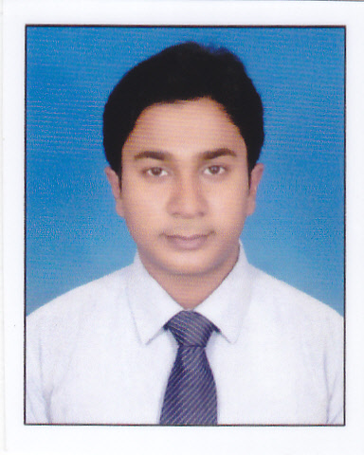
E-mail Address:
samyabratabiswas@gmail.com
Mobile No:
+91-7278849514
+91-9734470609

Seeking a challenging position where I can use my technical, management and personal skills for self-advancement and for the growth of the organization.

Academic Qualification
Course | College/Institute | Board/ University | Year of Passing | Marks (in%)
MBA (Marketing) | International Institute of Business Studies, Kolkata | Punjab Technical University | 2011-2013 | 64
Bachelor of Computer Application (B.C.A) | Sikkim Manipal University,  Tadong, Gangtok | Sikkim Manipal University | 2007-10 | 66.88
Higher Secondary [10+2] | Karimpur Jagannath High School, Nadia | W.B.C.H.S.E. | 2005-07 | 58.8
Madhyamik [Class X] | Karimpur Jagannath High School, Nadia | W.B.B.S.E. | 2005 | 72

Employment Details:

Company Name | Designation | Job Description | Location | Duration
Asian Paints Ltd. | Sales Officer | # Achieving Retail Sales target  # Enroll new Dealer  # Expanding new market area  # Up gradation of Existing Dealer scales.  # Maintaining relationships with existing Dealers  # Achieve Non Trade Sales Target  # Meet Engineers, Architects, Painters | Kolkata,  Nadia | Feb, 2014  to  Present

Personal Skills:

- Hard working & Responsible.
- Go Getting Attitude.
- Strong communication.
- Hardcore sales skills.
- Team player with an ability to grasp new things quickly.
- Ability to take tough decision.
- Willingness to learn always.

Summer Internship Project:
Project Name: Private vs. Non-Private Brands in Kids Section
Location: Pantaloons Retail India Ltd. of Kankurgachi Branch
Duration: 2nd July, 2012 to 31st Aug, 2012 (Two Months)

Computer Skills:
- MS-Office Suit, Photoshop 7.0, PageMaker 6.0
- Administrating Network System.
- Troubleshooting Technical Problems & Installation of Hardware & Software.
- Internet Savvy.

Personal Details:
Date of Birth: 1st May, 1990
Nationality: Indian
Marital Status: Married
Languages Known: English, Hindi & Bengali
Father’s Name: Mr. Sadhan Kumar Biswas
Permanent Address: Karimpur, Nadia, West Bengal
Current Address: Sodepur, N 24 Pargana, Kolkata, West Bengal

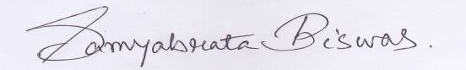

Date: Signature of the Candidate:

